**Assignment-7 [Loops]**

[Submitted by **Malika Hafiza Pasha**]

**Please implement Python coding for all the problems.**

1. Print the Palindromes (reverse of the number is itself) that are present in between 100 and 250. (Ex: 121,131,212,222... etc.)

**Answer:** [Python file is attached with the assignment file]

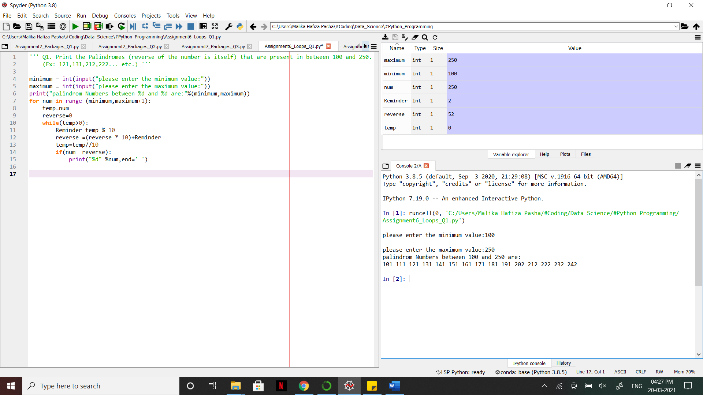

1. Consider a list1 [3,4,5,6,7,8]. Create a new list2 such that Add 10 to the even number and multiply with 5 if it is odd number in the list1.

**Answer:** [Python file is attached with the assignment file]

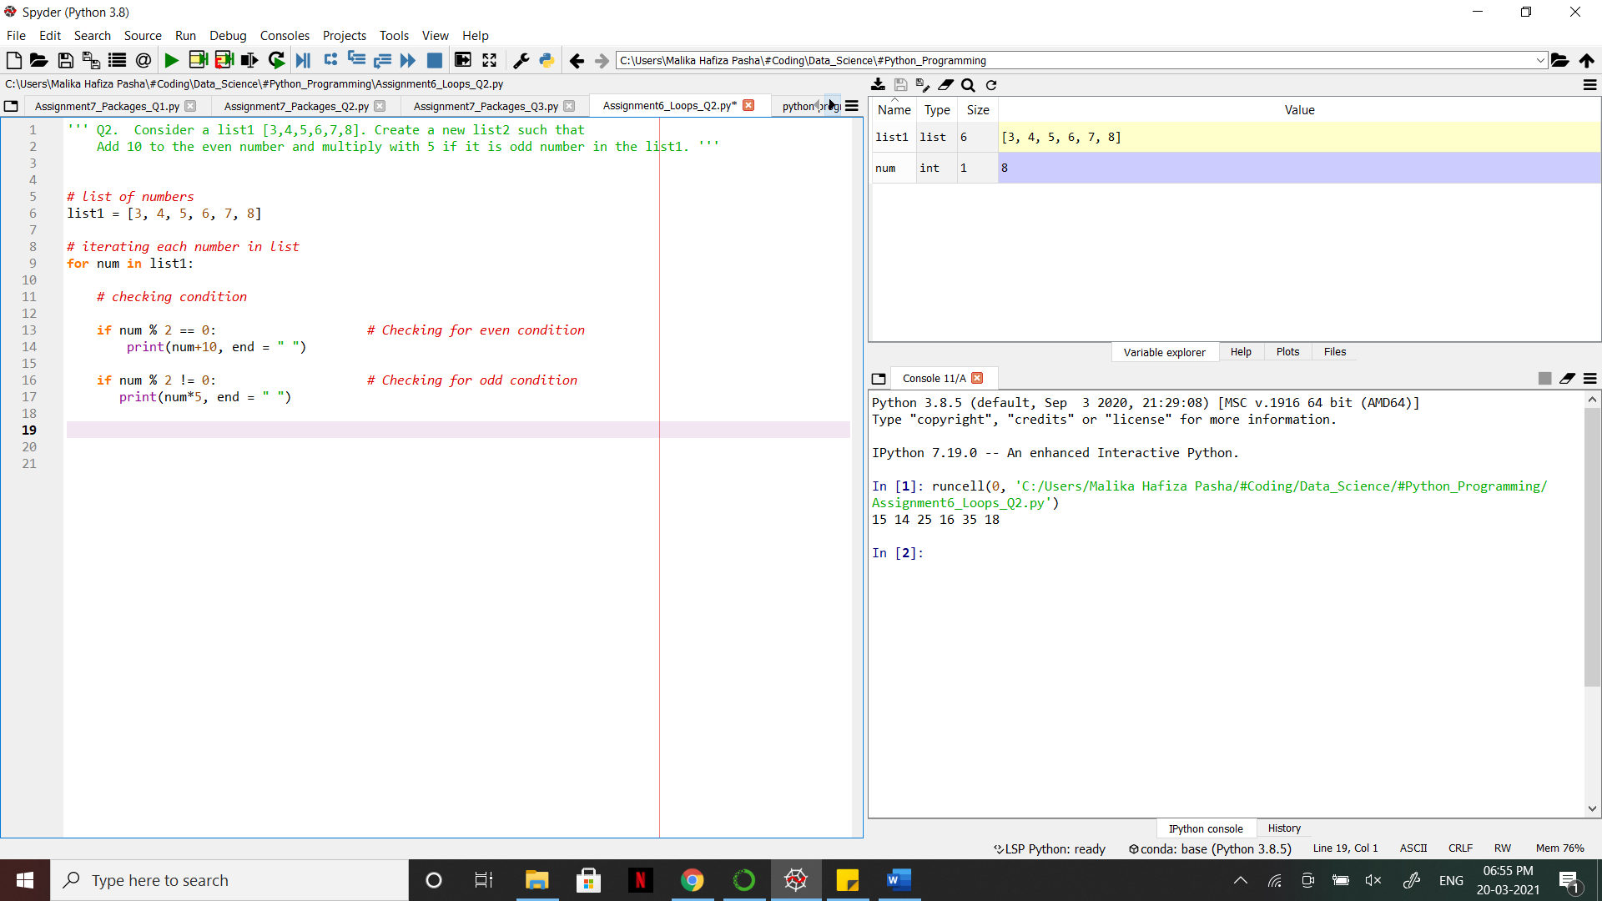

1. Consider a list [2,3,4,5,6]. Find the total sum of cumulative products of all the numbers in the list. (sum= 2*3 + 2*3*4 +....)

**Answer:** [Python file is attached with the assignment file]

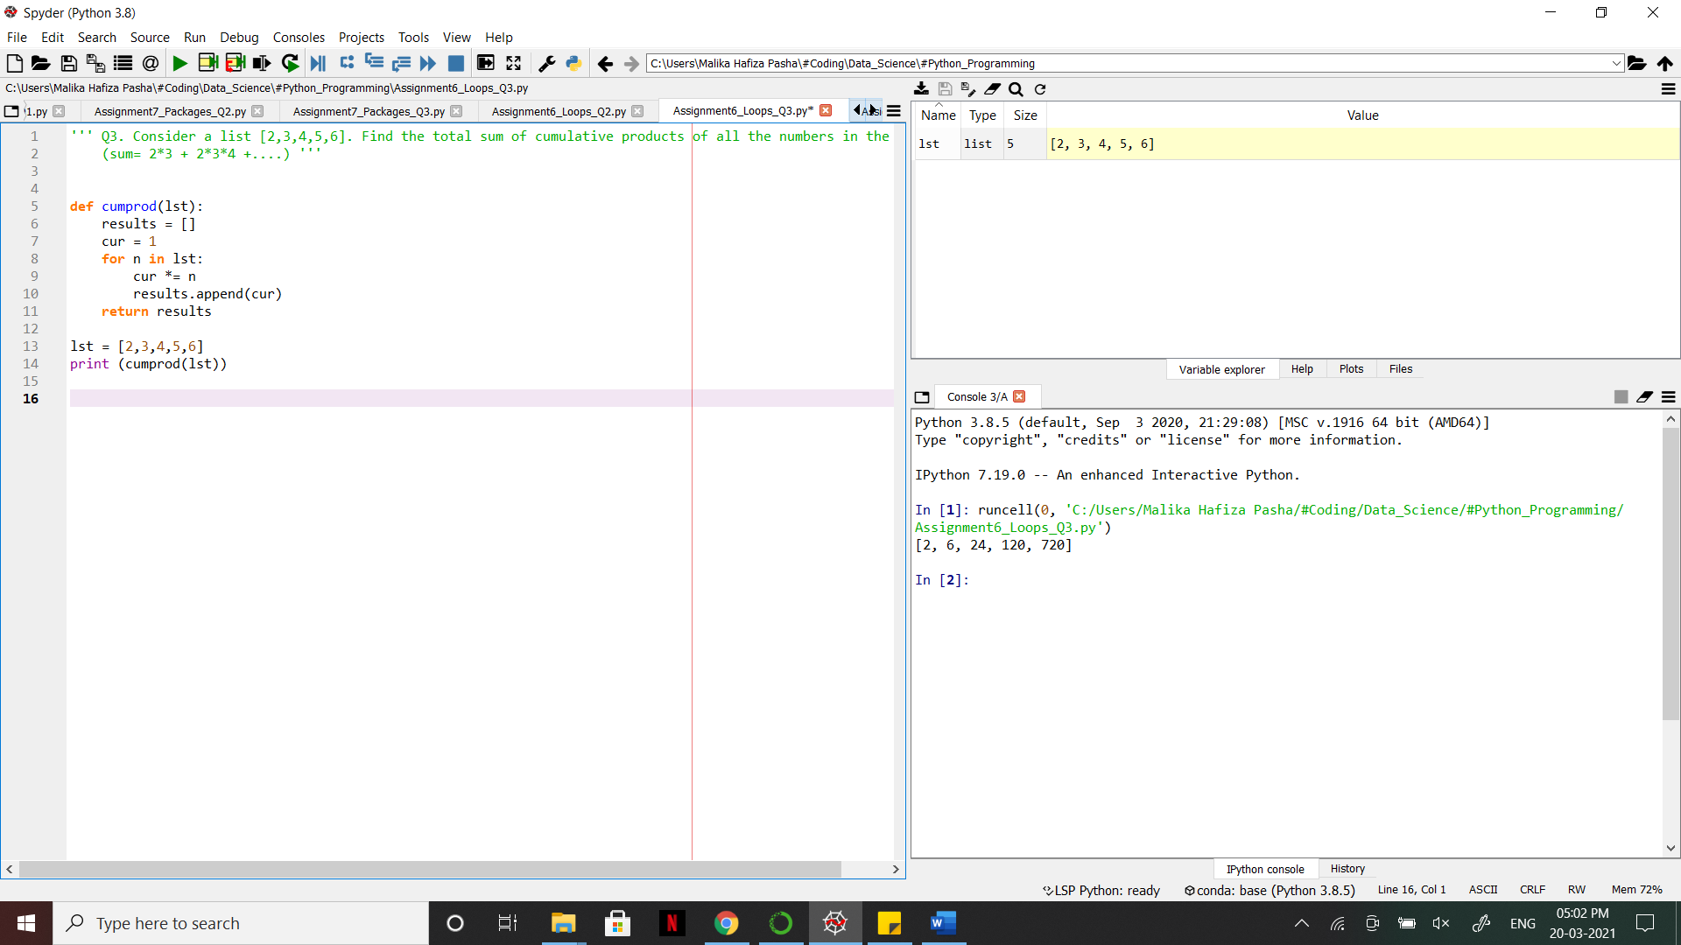

1. Create 2 lists. one list contains 10 numbers (list1=[0,1,2,3....9]) and other

list contains words of those 10 numbers (list2= ['zero', 'one', 'two',.... ,'nine']).

Create a dictionary such that list2 are keys and list 1 are values.

